**Example Instance**

This section gives a forward calculation example of the  for  with a makespan upper-bound constraint. It has eleven jobs , three factories , and three machines . The upper-bound of makespan is 99. The SDSTs ,  and  are shown in Table 2. ,  and  are shown in Table 3.

 

 

**Table 2** The values of  ,  and .

|  |  |  |  |  |  |  |  |  |  |  |  |
| --- | --- | --- | --- | --- | --- | --- | --- | --- | --- | --- | --- |
|  |  |  |  |  |  |  |  |  |  |  |  |
|  | 13 | 21 | 13 | 5 | 15 | 8 | 6 | 17 | 2 | 7 | 5 |
|  | - | 5 | 5 | 21 | 13 | 15 | 17 | 8 | 7 | 5 | 15 |
|  | 19 | - | 6 | 4 | 8 | 11 | 21 | 9 | 8 | 9 | 8 |
|  | 4 | 1 | - | 3 | 4 | 22 | 15 | 16 | 5 | 11 | 5 |
|  | 12 | 3 | 11 | - | 18 | 14 | 8 | 21 | 4 | 2 | 18 |
|  | 6 | 12 | 17 | 5 | - | 12 | 5 | 3 | 5 | 10 | 15 |
|  | 8 | 4 | 13 | 11 | 5 | - | 7 | 22 | 12 | 6 | 15 |
|  | 7 | 13 | 8 | 9 | 15 | 23 | - | 10 | 8 | 21 | 15 |
|  | 4 | 14 | 6 | 10 | 6 | 24 | 6 | - | 9 | 12 | 5 |
|  | 17 | 8 | 13 | 9 | 16 | 4 | 14 | 6 | - | 15 | 8 |
|  | 5 | 9 | 10 | 7 | 15 | 18 | 8 | 6 | 12 | - | 8 |
|  | 9 | 20 | 5 | 9 | 17 | 8 | 19 | 15 | 6 | 8 | - |
|  |  |  |  |  |  |  |  |  |  |  |  |
|  | 8 | 6 | 10 | 7 | 20 | 15 | 4 | 16 | 3 | 5 | 5 |
|  | - | 8 | 16 | 9 | 4 | 15 | 5 | 20 | 7 | 5 | 3 |
|  | 14 | - | 3 | 3 | 2 | 9 | 15 | 5 | 14 | 3 | 6 |
|  | 6 | 9 | - | 18 | 8 | 4 | 13 | 3 | 12 | 6 | 3 |
|  | 7 | 9 | 13 | - | 9 | 9 | 17 | 11 | 2 | 7 | 10 |
|  | 25 | 8 | 9 | 9 | - | 8 | 7 | 15 | 9 | 9 | 5 |
|  | 6 | 8 | 14 | 5 | 4 | - | 17 | 3 | 7 | 12 | 8 |
|  | 3 | 15 | 5 | 6 | 8 | 10 | - | 5 | 17 | 11 | 3 |
|  | 9 | 9 | 9 | 13 | 7 | 13 | 7 | - | 7 | 10 | 10 |
|  | 3 | 8 | 3 | 6 | 5 | 5 | 6 | 2 | - | 4 | 3 |
|  | 10 | 9 | 21 | 25 | 9 | 13 | 2 | 14 | 6 | - | 18 |
|  | 14 | 7 | 10 | 7 | 8 | 15 | 3 | 6 | 7 | 17 | - |
|  |  |  |  |  |  |  |  |  |  |  |  |
|  | 9 | 5 | 8 | 4 | 12 | 6 | 2 | 8 | 8 | 12 | 8 |
|  | - | 6 | 5 | 4 | 7 | 9 | 2 | 9 | 12 | 7 | 5 |
|  | 8 | - | 18 | 2 | 12 | 6 | 2 | 19 | 9 | 6 | 4 |
|  | 7 | 13 | - | 14 | 20 | 7 | 10 | 15 | 4 | 12 | 6 |
|  | 10 | 11 | 8 | - | 14 | 3 | 19 | 7 | 14 | 2 | 5 |
|  | 8 | 3 | 7 | 6 | - | 11 | 12 | 24 | 13 | 15 | 4 |
|  | 18 | 5 | 5 | 13 | 2 | - | 22 | 17 | 7 | 9 | 18 |
|  | 12 | 9 | 8 | 6 | 10 | 9 | - | 14 | 5 | 6 | 5 |
|  | 6 | 3 | 9 | 16 | 9 | 6 | 7 | - | 3 | 8 | 5 |
|  | 7 | 13 | 8 | 9 | 15 | 23 | 6 | 10 | - | 21 | 15 |
|  | 4 | 14 | 6 | 10 | 6 | 24 | 6 | 17 | 9 | - | 5 |
|  | 17 | 8 | 13 | 9 | 16 | 4 | 14 | 6 | 2 | 15 | - |

**Table 3** The energy consumption per unit time ,  and .

|  |  |  |  |  |  |  |  |  |  |  |  |
| --- | --- | --- | --- | --- | --- | --- | --- | --- | --- | --- | --- |
|  |  |  |  |  |  |  |  |  |  |  |  |
|  | 1 | 1 | 3 | 1 | 2 | 3 | 1 | 2 | 1 | 1 | 1 |
|  | - | 2 | 3 | 2 | 1 | 2 | 3 | 2 | 1 | 3 | 3 |
|  | 3 | - | 2 | 1 | 1 | 2 | 1 | 3 | 2 | 2 | 2 |
|  | 3 | 1 | - | 2 | 3 | 2 | 2 | 3 | 1 | 1 | 1 |
|  | 3 | 2 | 1 | - | 2 | 3 | 1 | 2 | 3 | 1 | 3 |
|  | 3 | 3 | 1 | 3 | - | 2 | 2 | 1 | 2 | 2 | 3 |
|  | 1 | 2 | 1 | 2 | 1 | - | 3 | 2 | 1 | 3 | 3 |
|  | 1 | 3 | 2 | 3 | 2 | 1 | - | 2 | 3 | 3 | 1 |
|  | 2 | 2 | 1 | 2 | 3 | 1 | 3 | - | 1 | 2 | 2 |
|  | 3 | 1 | 2 | 3 | 2 | 1 | 3 | 1 | - | 1 | 3 |
|  | 2 | 2 | 1 | 2 | 3 | 1 | 2 | 3 | 2 | - | 2 |
|  | 3 | 2 | 1 | 1 | 1 | 2 | 1 | 1 | 3 | 2 | - |
|  |  |  |  |  |  |  |  |  |  |  |  |
|  | 1 | 3 | 2 | 2 | 2 | 2 | 1 | 3 | 2 | 2 | 3 |
|  | - | 2 | 2 | 1 | 1 | 2 | 3 | 1 | 3 | 3 | 1 |
|  | 2 | - | 3 | 1 | 2 | 3 | 2 | 1 | 3 | 2 | 1 |
|  | 2 | 1 | - | 3 | 1 | 3 | 1 | 2 | 3 | 1 | 3 |
|  | 3 | 3 | 1 | - | 3 | 2 | 1 | 3 | 1 | 2 | 2 |
|  | 1 | 3 | 2 | 1 | - | 2 | 2 | 1 | 2 | 3 | 3 |
|  | 2 | 2 | 1 | 2 | 3 | - | 2 | 1 | 3 | 3 | 3 |
|  | 3 | 2 | 1 | 1 | 1 | 2 | - | 1 | 3 | 1 | 1 |
|  | 1 | 3 | 2 | 3 | 2 | 1 | 2 | - | 1 | 2 | 1 |
|  | 2 | 3 | 1 | 1 | 3 | 2 | 1 | 3 | - | 1 | 1 |
|  | 2 | 1 | 1 | 3 | 2 | 2 | 1 | 2 | 3 | - | 1 |
|  | 2 | 3 | 2 | 1 | 2 | 3 | 1 | 3 | 2 | 3 | - |
|  |  |  |  |  |  |  |  |  |  |  |  |
|  | 3 | 1 | 3 | 2 | 1 | 3 | 1 | 1 | 1 | 1 | 2 |
|  | - | 3 | 2 | 3 | 1 | 3 | 2 | 1 | 3 | 3 | 1 |
|  | 2 | - | 1 | 3 | 2 | 2 | 1 | 2 | 3 | 2 | 3 |
|  | 1 | 2 | - | 3 | 1 | 2 | 1 | 3 | 2 | 1 | 1 |
|  | 1 | 3 | 2 | - | 1 | 2 | 1 | 2 | 2 | 1 | 1 |
|  | 1 | 2 | 1 | 2 | - | 3 | 3 | 2 | 1 | 2 | 2 |
|  | 3 | 2 | 1 | 1 | 2 | - | 2 | 3 | 1 | 3 | 3 |
|  | 2 | 2 | 1 | 2 | 2 | 3 | - | 2 | 3 | 2 | 2 |
|  | 1 | 3 | 1 | 3 | 2 | 3 | 1 | - | 2 | 3 | 1 |
|  | 2 | 2 | 1 | 2 | 3 | 1 | 3 | 2 | - | 2 | 2 |
|  | 3 | 1 | 2 | 3 | 2 | 1 | 3 | 1 | 1 | - | 3 |
|  | 2 | 2 | 1 | 2 | 3 | 1 | 2 | 3 | 2 | 1 | - |

According to the above MILP model, Fig. 2 presents the Gantt chart depicting the optimal solution obtained through the Gurobi solver. The horizontal axis represents the completion time of jobs, and the vertical axis represents machines of each factory. The optimal sequence ,  and .According to Eqs. (19)-(21), the decoding process is given for detail.

In factory 1,  = 7,  = 13,  = 22,  = 18,  = 24,  = 36,  = 41,  = 46,  = 57,  = 52,  = 57,  = 63,  = 66,  = 73,  = 89,  = 85,  = 95,  = 99,  = 7,  = 13,  = 22,  = 18,  = 32,  = 36,  = 41,  = 46,  = 57,  = 52,  = 59,  = 63,  = 66,  = 77,  = 89,  = 85,  = 95,  = 99.

In factory 2,  = 12,  = 17,  = 22,  = 28,  = 41,  = 48,  = 47,  = 59,  = 66,  = 12,  = 18,  = 22,  = 28,  = 41,  = 48,  = 47,  = 59,  = 66.

In factory 3,  = 15,  = 19,  = 27,  = 29,  = 44,  = 48,  = 15,  = 19,  = 27,  = 29,  = 44,  = 48.

 is composed of three parts, i.e., , , and . In factory 1, *TPE1* = 454, *TSE1* = 179, *TIE1* = 176, *ECC*1= 454+179+176 = 809. In factory 2, *TPE2* = 478, *TSE2* = 210, *TIE2* = 234, *ECC*2 = 478+210+234 = 922. In factory 3, *TPE3* = 342, *TSE3* = 279, *TIE3* = 294. *ECC*3 = 342+279+294 = 915. Thus,  = 922.

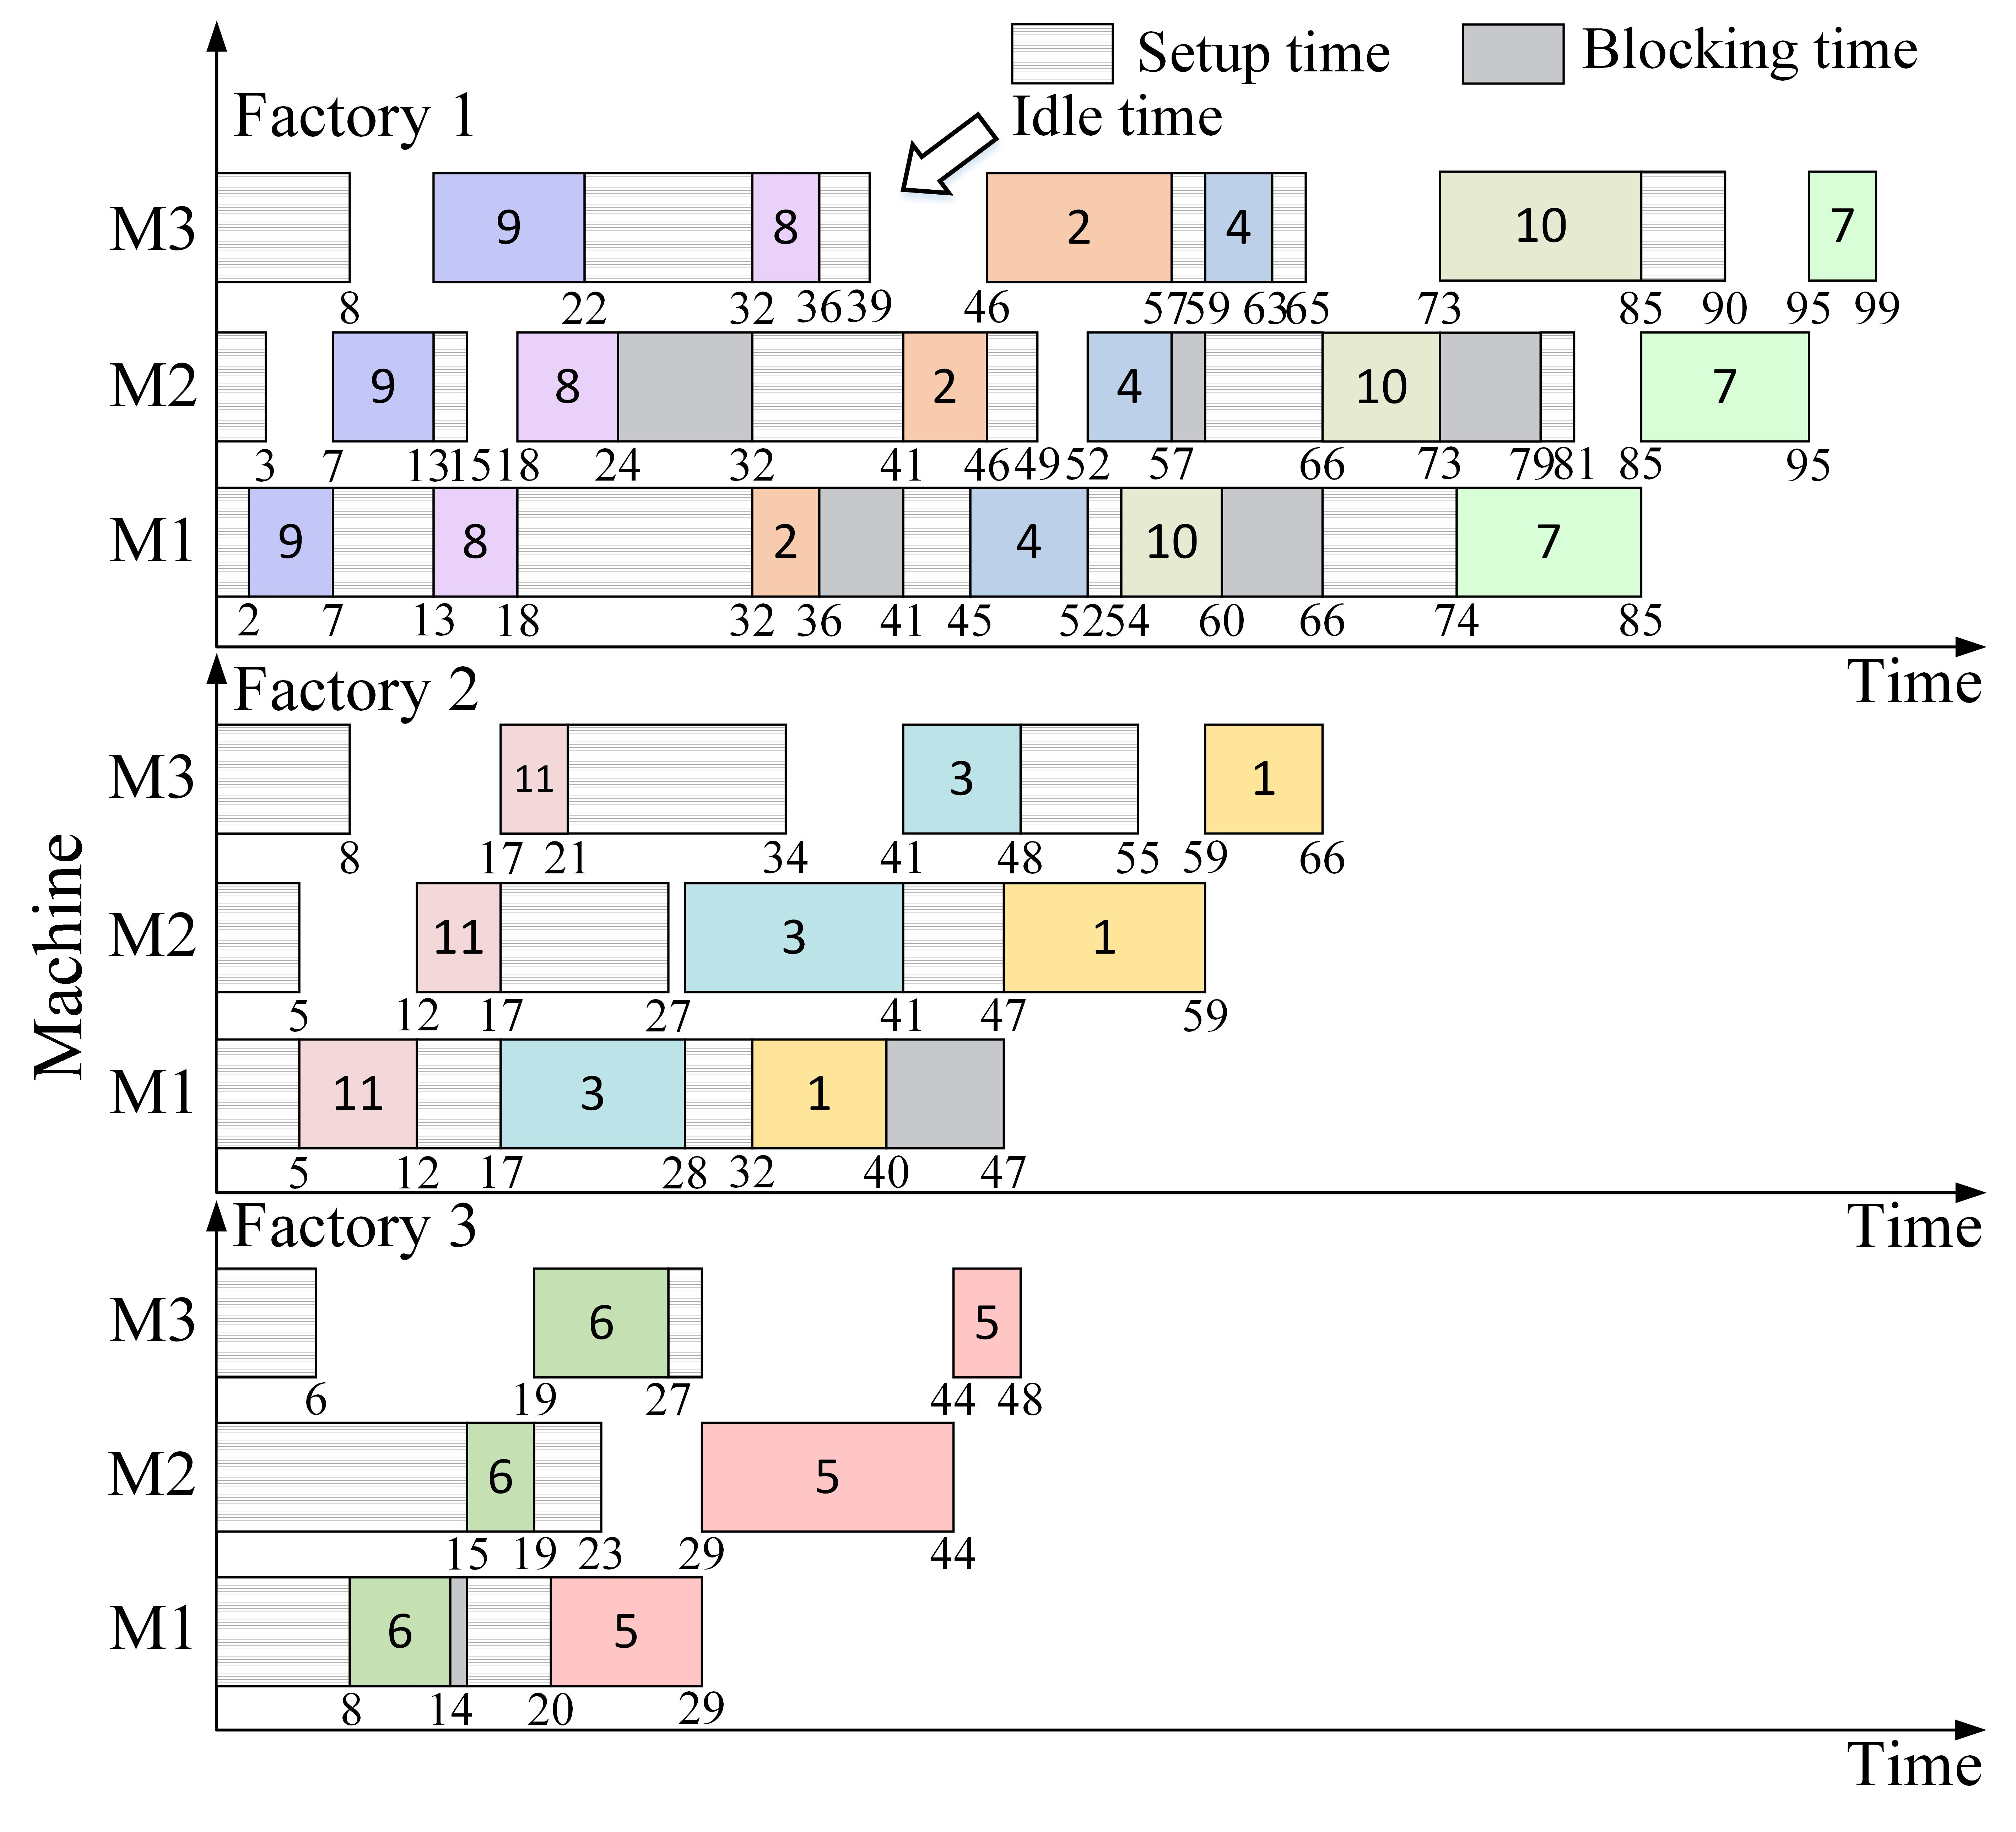

**Fig. 2** The Gantt chart for forward calculation example.